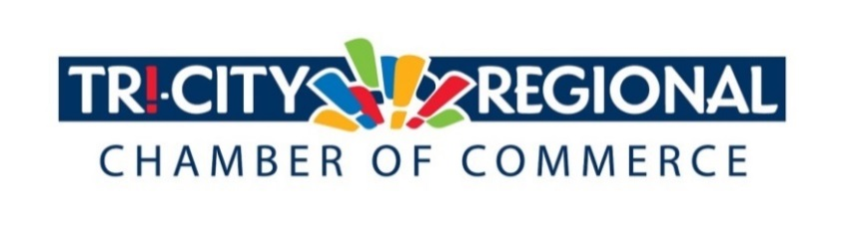
CANDIDATE QUESTIONNAIRE
2018 GENERAL ELECTION

Position:_______Benton County Commissioner___________________

Candidate:_____Lori Sanders________________________________

Biographical Information:

- Education/Past & Present Employment/Business Experience
I received my Associate of Science Degree in Engineering Technology from Columbia Basin College. My husband and I have owned and operated our businesses for the past 30+ years. Although we share many responsibilities, I am primarily responsible for the operation of Energy Incentives, INC., a national award winning company that has twice been recognized by the Environmental Protection Agency as an Energy Star Partner of the Year. Energy Incentives, INC. has been in operation for 32 years offering inspection services to local jurisdictions as well as Energy Star verification for new construction.

Another business we own is a commercial laundry service in Las Vegas. My role in this business is now limited due to time constraints, but it has been an amazing experience to build a business of this size from the ground up.

- Past & Present Community Involvement

Most of my community service is through my church, Hillspring (formally Cathedral of Joy). I’m active in the Living Nativity production, a former Sunday school teacher, and youth class pastor. I am also a member of Soroptimist International Three Rivers, Women in Nuclear, and a founding member of Corem Deo, which is a co-operative Classical Christian School. I am currently serving my 3rd term as a Benton PUD Commissioner and served 8 years on the Executive Board of Energy Northwest.

Candidate Questionnaire:

- Why are you running for office?

Over the past few years, I have noticed what seems to be a lack of effective leadership in the county government. Negative headlines, settled and pending lawsuits, low employee moral all seem to be the norm. I am passionate about good governance and believe that I can make a difference for the benefit of our community.

- What have you done to prepare for this position?

14 years ago I was elected to be Benton PUD Commissioner. During that time, I served 4 years as President of the Commission, my areas of interest have been strategic planning, risk management, and financial policy. I was also honored to serve 8 years on the Executive Board of Energy Northwest. During that time I oversaw an annual budget of over $1.2 billion (which is 10 X the county budget). I’m familiar with revenue, debt, and risk management structures that are often used in public entities.

In both of these positions I have become known for asking important challenging questions of staff. I seek out information from a variety of sources and am willing to delay decisions if issues are not thoroughly vetted. At the same time, I have been a strong advocate for both organizations and the staff who work there.

- What are three actions you would support to strengthen small business and entrepreneurship?

- I will always be aware of the fact that money sent to the County is money removed from your businesses. I’ll budget funds efficiently and effectively. For many years my husband and I would send in more money for business taxes then we were able to give to ourselves. I know the sacrifice that a business owner makes when he or she pays taxes and I will be humble enough to respect that.
- Economic Development is the one area that pays dividends back to a community. As a serial entrepreneur you will not have to convince me of the value that small business brings. I recently attended a Benton County Commission meeting where the Port of Kennewick was seeking money for infrastructure in Vista Field. One of the Commissioners actually voted against this and said “If we give this money out, we soon won’t have any left in the economic development fund.” I was surprised by this statement. If you give the money wisely, and thoroughly vet proposals brought forward, your goal should be to spend down the economic development funds, not keep it! The money only works when it is invested in the community, not sitting in the bank for the County.
- I will listen to your ideas. I know my own business and I know the regulations that can impede productivity. But I don’ t know your business. It sounds like an easy task, yet it happens far too infrequently. Listening is the first step to good leadership. Tell me what you need to be successful.
- Share your innovative ideas with me. Here’s an example of an innovative idea. Can we develop a niche market for remote workers? My son-in-law works from his home in Kennewick for a software company in Bellevue. They couldn’t find affordable housing on the west side and they wanted to be closer to family. He proposed working remotely and his company agreed. Now we have new money coming into the community with more dollars to churn the economy. Maybe we should focus our efforts on bringing more remote workers to this area.

- What do you believe is the greatest economic challenge facing our region and what would be your approach to address it?
Over regulation of our businesses and resources. I view the role of Commissioner as being an advocate for business and people to help them become successful, not a regulator who polices you.

- If elected, what will be your top two priority issues and how will you facilitate these changes and/or ideas?

- First and foremost is the need for effective leadership. Starting with strategic planning that has community input from stakeholders, next would be setting goals for the county, then prioritize budgets according to the goals. I understand that I will be just 1 of 3 commissioners. My leadership style is to work collaboratively with all stakeholders, including my peers.
- Since starting my campaign I have been asking for feedback and listening to my constituents. I did a survey on my Facebook page asking people to rank services provided by the county. I was surprised to see that 75% ranked “access to mental healthcare” as their top concern. I suspected that a local advocate had sent people to the poll and perhaps the poll was not really a good representation. However, I have gotten a similar response on another poll that I did at the Benton County Fair. Once again, access to mental healthcare was the overwhelming top concern. This tells me that maybe our community is finally ready to do something about this issue. Perhaps we should spend some of the excess public safety tax on an assessment of the needs of our community concerning mental healthcare. Start with a needs assessment, develop a roadmap for solutions, begin the task of seeking funding (or moving funding), and implement solutions. All of which requires community input, collaboration, and good solid leadership.

- Over 4500 Tri-Citians have already participated in the MyTri2030 Regional Vision project by helping to identify big opportunities that will benefit the entire region. In principle, do you support this community-driven effort? And as goals emerge, would you be interested in working together to advance regional initiatives?

I have participated in the MYTri2030 survey. I think this is a fantastic tool to gage the priorities of the community. I’m very interested in the results and look forward to working with the Tri Cities Regional Chamber in developing initiatives and common goals for our community.

*Please attach a headshot photo with your submission*
A one-minute (max) campaign video may be submitted with questionnaire responses
Please return all responses by Wednesday, September 26th
Via e-mail to: stephanie.swanberg@tricityregionalchamber.com
Via fax: (509) 783-1733
Via mail: 7130 W. Grandridge Blvd., Suite C | Kennewick, WA 99336

Thank you for completing the questionnaire!

