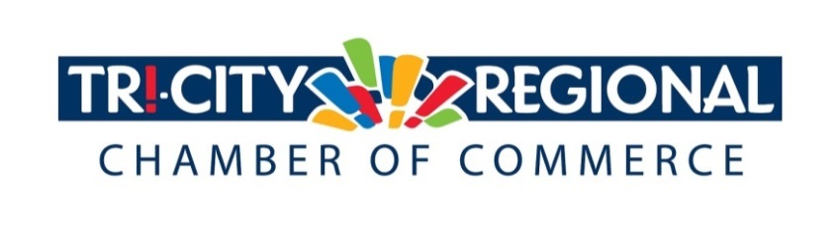
CANDIDATE QUESTIONNAIRE
2018 GENERAL ELECTION

Position:___Rebecca Francik _________________________________

Candidate:__House of Representatives 16th LD Pos. 2 ______________

Biographical Information:

- Education/Past & Present Employment/Business Experience

- B.S. Agronomy WSU
- Wife of 40 years, mother to 7 children
- Master’s in Teaching Heritage University
- Master’s in library and Information Science U of W
- Pasco City Councilmember 21 years
- Member of Pasco Parks and Rec, TRAC, Leoff 1 and old Fireman pension fund
- 12 years Association of Washington Cities Board member
- Nationally Board-Certified Librarian/Teacher

- Past & Present Community Involvement
  - Member of Mid-Columbia Master Singers
  - Member of Mid-Columbia Musical Theatre

Candidate Questionnaire:

- Why are you running for office?
Government services impact each of our lives, positively if they are delivered correctly and negatively if they are incorrectly targeted or funded. As a council member I have seen the legislature ignore local needs even when the request had no cost to the state.

Issues such as exempting themselves from the Public Records Act when they expect local governments to comply lead to a lack of transparency at the state level and distrust by our citizens. The state should be willing to live by the same regulations they require of everyone else. Delaying action on the McCleary decision until the 11th hour has negatively impacted children across the state. Crafting an education solution with little stakeholder input is leading several districts to wonder if they will be bankrupt. School funding will need to be addressed as an important investment in our state’s future. Continuing to pass unfunded mandates to city and county governments has made it increasingly difficult for local jurisdictions to provide the services their citizens need. We can do better! As someone with extensive experience in municipal services, education, agriculture and state infrastructure I can be an effective voice for our community. It is also important that Eastern Washington has a voice in the majority caucus. I am well qualified to fill that role.

- What have you done to prepare for this position?
My entire career has prepared me for this position. I have a degree in Agronomy, have worked in Agriculture, raised 7 children who attended public schools, and later became a nationally board-certified librarian/teacher working in those same public school. I have worked as an elected leader for 21 years, serving on two state infrastructure boards building water and sewer systems, roads and bridges throughout the state including the:
- Kartchner Road Overpass on US 395
- Red Mountain Interchange on I-82
- US 12 Walla Walla Road Improvements

Under my watch as a council member Pasco saw:

- Over 80% reduction in crime
✓ Thousands of dollars saved in decreased property taxes
✓ Coordinated expansion of Water, Sewer, and other City Services as Pasco’s population more than doubled
✓ Significant investment in Pasco’s Downtown
✓ Creation and expansion of Pasco’s Food Processing Center
✓ Collaboration with the Department of Natural Resources to develop farm circles in Pasco’s Urban Growth Area
✓ Millions of transportation dollars invested to bring industrial development and jobs to Southeastern Washington

- What are three actions you would support to strengthen small business and entrepreneurship?
  - I will whole heartedly support the AWB’s call for $190 Billion of infrastructure investments in Washington over the next 20 years
  - I Will support fair tax structures that treat large and small businesses equally
  - I Will support high quality education and post-secondary education including apprenticeship programs so businesses have the employees they need.

- What do you believe is the greatest economic challenge facing our region and what would be your approach to address it?
Infrastructure needs: including water, sewer, broadband internet and power delivery systems, along with transportation networks especially roads and bridges in our rural communities are going to be the greatest future economic challenges in our region.

Figuring out a fair and sustainable system to maintain our roads and build new ones in a non-partisan manner is one of my top priorities. I would like to run a bill asking for a constitutional amendment making it impossible for the legislature to raid the public works trust fund in the future, so our local communities have a reliable source of infrastructure funding.

A lack of affordable housing is causing many difficulties within out community. Looking at zoning, figuring out ways to incentivize building more affordable homes and bringing higher paying wages to Eastern Washington are all on my list of things to work on.

- If elected, what will be your top two priority issues and how will you facilitate these changes and/or ideas?
- My top two priorities when elected will be to propose a constitutional amendment making the Public Works trust fund unavailable for raiding.
- My second priority will be convening a wide net of stake holders in education and figuring out how to fix McCleary before many of our school districts go bankrupt.

- Over 4500 Tri-Citians have already participated in the MyTri2030 Regional Vision project by helping to identify big opportunities that will benefit the entire region. In principle, do you support this community-driven effort? And as goals emerge, would you be interested in working together to advance regional initiatives?

Absolutely! I was one of the people who took the survey. I am a member of this community and care deeply about its future for myself and my fellow citizens. I have long been a supporter of a regional vision for the Tri-Cities and applaud letting that vision be driven by the people who live here.

*Please attach a headshot photo with your submission*
A one-minute (max) campaign video may be submitted with questionnaire responses
Please return all responses by Wednesday, September 26th
Via e-mail to: stephanie.swanberg@tricityregionalchamber.com
Via fax: (509) 783-1733
Via mail: 7130 W. Grandridge Blvd., Suite C | Kennewick, WA 99336

Thank you for completing the questionnaire!

