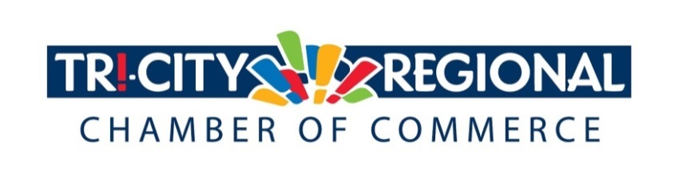
CANDIDATE QUESTIONNAIRE
2018 GENERAL ELECTION

Position: Washington State Representative for District 9

Candidate: Jenn Goulet

Biographical Information:

- Education/Past & Present Employment/Business Experience

I have a Bachelor of Applied Science degree in Applied Management. I have my own business developing online training for Microsoft. Formerly I worked for many years as a technical writer/editor, then as an instructional designer/training specialist, for Department of Energy contractors, most recently at the HAMMER Federal Training Center.

- Past & Present Community Involvement

I have served on several nonprofit and political boards and committees and cofounded a 501(c)3 nonprofit, the Tri-City Freethinkers, of which I was the president until I resigned last fall to run for office again. I have been and remain a member of the board of directors of Planned Parenthood of Greater Washington and North Idaho since January 2016. I am the former chair of the Franklin County Democratic Central Committee. In my various roles, I have been a champion for the rights of women, minorities, LGBT individuals, and others. I’ve mobilized members of my community to stand in opposition to racism, religious bigotry and oppression, fearmongering, and hatred. I have staged political demonstrations and lobbied for causes in Olympia and in Washington DC.

Candidate Questionnaire:

- Why are you running for office?

As a Legislator, I will be in a position to make a meaningful difference in the lives of the people in my district whose voices aren’t being heard in Olympia right now.

- What have you done to prepare for this position?

I’ve been involved in politics for several years, including as the chair and vice chair of the local Democratic party, and so have a greater than average understanding of the issues facing the 9th LD and the state, as well as a greater than average understanding of how the government, specifically the Legislature, functions.

- What are three actions you would support to strengthen small business and entrepreneurship?

Our communities are growing and we need to provide good, family-wage jobs in order to strengthen them for the future. I want to encourage tech, green energy, and other industries to settle in our district and to fund programs that would provide entrepreneurs and startups financing to help launch businesses in areas where such incentives would have a high return on investment for the community as a whole.

- What do you believe is the greatest economic challenge facing our region and what would be your approach to address it?

To pass laws and balance the budget in a way that has a net positive affect on constituents’ lives, striking a balance between the interests of the residents of our state and businesses that operate within it, while responsibly caring for the environment in which we all must live.

- If elected, what will be your top two priority issues and how will you facilitate these changes and/or ideas?

Two of my platform points are education and infrastructure. For education: In Washington, we need to increase funding for our universities and community colleges so young people aren’t going deep into debt to afford a higher education, and we need to expand trade school and union apprenticeship programs for high school students so they can have more opportunities to succeed and meet the demands of our state’s industries. For infrastructure: Washington State’s aging transportation infrastructure needs revitalization and expansion to accommodate for a rapidly growing population. This isn’t just an investment in the economy; it’s a vital public safety issue.

- Over 4500 Tri-Citians have already participated in the MyTri2030 Regional Vision project by helping to identify big opportunities that will benefit the entire region. In principle, do you support this community-driven effort? And as goals emerge, would you be interested in working together to advance regional initiatives?

Yes, I do support it and would like to work together to advance the region’s initiatives!

*Please attach a headshot photo with your submission*
A one-minute (max) campaign video may be submitted with questionnaire responses
Please return all responses by Wednesday, September 26th
Via e-mail to: stephanie.swanberg@tricityregionalchamber.com
Via fax: (509) 783-1733
Via mail: 7130 W. Grandridge Blvd., Suite C | Kennewick, WA 99336

Thank you for completing the questionnaire!

