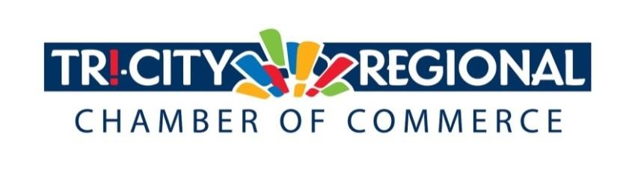
CANDIDATE QUESTIONNAIRE
2018 GENERAL ELECTION

Position: State Representative, Pos. 1
Candidate: William “Bill” Jenkin

Biographical Information:

- Education/Past & Present Employment/Business Experience

Education: B.A. Business Management-University of Redlands
Employment/Business Experience: Financial Advisor at Edward Jones Investments (AAMS Designation), Owner of Prosser Vineyard & Winery, Real Estate Investor, Founder of Bills Tasting Room (Wine and Cheese Shop).

- Past & Present Community Involvement

Rotary District Governor - District 5060 (2017-2018), Founding Chairman of Prosser Boys & Girls Club, Prosser Chamber of Commerce President (2011-2013), Prosser Economic Development Association (2011-2016), People for People Board Member (Current), Prosser United Good Neighbor President (2014), Prosser United Good Neighbor Member (2012-2015)

Candidate Questionnaire:

- Why are you running for office?

I am running to office to ensure Eastern Washington is strongly represented in policy and budget discussions in Olympia. As a small business owner, I understand the challenges facing entrepreneurs and want to continue bringing my experience to those discussions. I want to help people and will continue advocating for policies that allow our community to thrive.

- What have you done to prepare for this position?

As an incumbent, I have worked hard over the past two years to position our district as a leader in the state. I have worked with colleagues across the aisle to educate them about how decisions made in Olympia affect our community. My first term has been focused on learning, listening and building relationships to be an effective legislator.

- What are three actions you would support to strengthen small business and entrepreneurship?

I continue to believe that our state needs to reform the Business and Occupation Tax. It needs to be reduced or eliminated altogether. Taxing gross revenues is a burden for entrepreneurs, and a job killer. I support tax policies that are fair, such as giving the same rate Boeing pays to all manufacturers. A third action I support to strengthen small business and entrepreneurs is to reduce regulatory burdens. Compliance with the numerous administrative rules is costly for small businesses.

- What do you believe is the greatest economic challenge facing our region and what would be your approach to address it?

Over regulation from Olympia is a growing problem that impacts small businesses and entrepreneurs. They cost time and money for small business that they can’t afford. My approach is to ensure our community’s priorities are considered.

- If elected, what will be your top two priority issues and how will you facilitate these changes and/or ideas?

As a member of the state Tourism Board, I will continue to promote our district as a great place to live, work, and visit. I will continue to focus on my three overarching priorities of agriculture, education, and supporting local businesses through the committees on which I serve.

- Over 4500 Tri-Citians have already participated in the MyTri2030 Regional Vision project by helping to identify big opportunities that will benefit the entire region. In principle, do you support this community-driven effort? And as goals emerge, would you be interested in working together to advance regional initiatives?

Yes. We can accomplish a lot by collaborating and putting the skills of our community to work. I am very interested in staying engaged and supporting goals that help improve our region.

*Please attach a headshot photo with your submission*
A one-minute (max) campaign video may be submitted with questionnaire responses
Please return all responses by Wednesday, September 26th
Via e-mail to: stephanie.swanberg@tricityregionalchamber.com
Via fax: (509) 783-1733
Via mail: 7130 W. Grandridge Blvd., Suite C | Kennewick, WA 99336

Thank you for completing the questionnaire!

