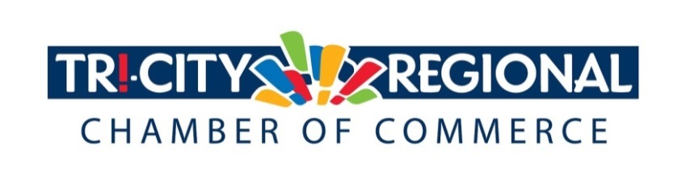
CANDIDATE QUESTIONNAIRE
2018 GENERAL ELECTION
House of Representatives, District 8, Pos. 1
Position:_____________________________________________________________
Brad Klippert
Candidate:___________________________________________________________

Biographical Information:

- Education/Past & Present Employment/Business Experience

Masters Degree: Teaching
Bachelors Degree: Behavioral Science/Biblical Studies
Nationally Certified Paramedic/Emergency Medical Technician
Rotary Wing & Fixed Wing Pilot

- Past & Present Community Involvement

Sheriff’s Deputy/School Resource Officer
Commander: WA State Guard
Engineer/Conductor: J&S Express
Facilitated numerous Veteran’s Day Assemblies
Facilitated and participated in numerous Every 15 Minute Programs
Candidate Questionnaire:

- Why are you running for office? I don’t like the direction our state is going. Seattle City Council decisions and west side Judges’ decisions trying to move across the state. To protect our eastern Washington values, principles and beliefs.

- What have you done to prepare for this position?
10 years of elected service

- What are three actions you would support to strengthen small business and entrepreneurship?

Oppose any additional business: 1. Taxes
2. Regulations that hamper growth or prosperity
3. Oppose carbon tax

- What do you believe is the greatest economic challenge facing our region and what would be your approach to address it?
Carbon Tax: We must vote no and oppose this.
People must run for office and support other fiscal conservatives who do not support increased taxing of our citizens.

- If elected, what will be your top two priority issues and how will you facilitate these changes and/or ideas?

Public Safety: Protect Law Enforcement/Criminal Justice personnel to be able to do their jobs and protect the law abiding citizens of this state.
No new taxes: Protect businesses from new, harmful taxes.
Get people involved: Fight to keep fiscal conservatives in office.

- Over 4500 Tri-Citians have already participated in the MyTri2030 Regional Vision project by helping to identify big opportunities that will benefit the entire region. In principle, do you support this community-driven effort? And as goals emerge, would you be interested in working together to advance regional initiatives?

Yes, Absolutely Yes!!

*Please attach a headshot photo with your submission*
A one-minute (max) campaign video may be submitted with questionnaire responses
Please return all responses by Wednesday, September 26th
Via e-mail to: stephanie.swanberg@tricityregionalchamber.com
Via fax: (509) 783-1733
Via mail: 7130 W. Grandridge Blvd., Suite C | Kennewick, WA 99336

Thank you for completing the questionnaire!

