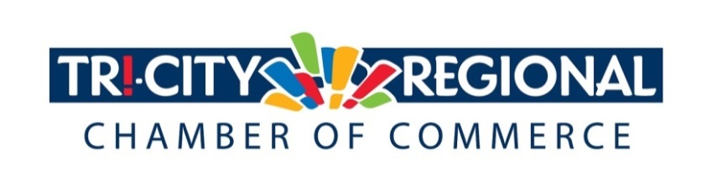
CANDIDATE QUESTIONNAIRE
2018 GENERAL ELECTION

Position: State Representative, 9th District, Position 1

Candidate: Mary Dye

Biographical Information:

- Education/Past & Present Employment/Business Experience

Bachelor’s of Science, Plant Science/Crop Management, University of Idaho 1983
State Representative, 2015-Present
Co-Owner with Roger Dye of 3000 Acre Dry-land Wheat Farm in Garfield County, Washington 1987- Present
Field Consultant, Spectrum Crop Management, Ralston, Washington, 1987
Peace Corps Volunteer, Center for Non-Formal Education, Ubon Rajithani, Thailand, 1984-1986

- Past & Present Community Involvement

Past President of Garfield County Wheat Growers
Former Board Member of Washington Association of Wheat Growers
Past President of Garfield County Crop Improvement
Superintendent of Poultry and Rabbits, Garfield County Fair
4-H Leader for Feathers and Fur 4-H Club
Served on the Human Services Board for Garfield County
Served on the Advisory Committee for WSU Sustainable Agriculture Center
Elected to the Washington State Republican Party Central Committee as State Committee Woman, 1992-Present
Elected to the Washington State Republican Party Executive Board, May 2018-Present
Elected to the Washington State Republican Party Vice Chairwoman, 1994-1996
Appointed to Serve as Platform Chair for WSRP in 2000 and 2004
Served on Republican National Committee Platform and Co-Chaired the Ag, Energy and Natural Resources, 2012

Candidate Questionnaire:

- Why are you running for office?

I have a deep passion for the American Values that have kept our country free and prosperous for 2 and ½ centuries. I am a strong voice for people who still believe in our system of government and I am working to protect my constituents from taxation and regulation that stifles our hard working citizens and puts more unnecessary burdens on all of our lives. I believe in the power of the free enterprise system to lift and improve the lives of all of our citizens. I wish to continue to develop and advocate for policies that give more opportunities to risk takers and entrepreneurs and those who work for the great companies that provide the prosperity we all enjoy in the State of Washington. I am bold in speaking truth to those who seek power against the freedoms of my constituents and I seek to limit and reduce the administrative state and see it as a perennial threat to our liberties. Those who are willing to take risks and pursue their gifts and passions should be free to develop, innovate and prosper. The threat of regulatory repercussions can intimidate people who otherwise may have found the joy of the free enterprise system. I seek to reverse this trend towards people choosing the security of public employment and hope to invigorate exciting opportunities in the private sector.

- What have you done to prepare for this position?

I have written Platforms for the Republican Party since 1994. As a result, I am rooted in principle. I evaluate every policy based on the grounding principles of our Constitution and I have a sense of human nature and how the spirit of the people is affected by policies that liberate or regulate. I wrote Freedom to Farm Act to express the need to liberate the commodity farmers from the central planning policies of Franklin D. Roosevelt. I continue to develop policies and strategies that reinvigorate citizens and restore their American birthright of liberty and self-determination within the law.

When I think about it, my whole life prepared me to serve in elected office. I have found great satisfaction in helping people in my district and continue to see possibilities for good in the next term.

- What are three actions you would support to strengthen small business and entrepreneurship?

- I would work to keep our energy supplies abundant, encouraging the use of the most cost effective sources of power generation.
- I would reduce the time for permitting from years to weeks. I would build in certainty in the permitting process and eliminate unnecessary permits.
- I would advocate for the removal of the B&O tax.

- What do you believe is the greatest economic challenge facing our region and what would be your approach to address it?

Nearly every sector in our state’s economy is facing the uncertainty brought on by the threats to tax and regulate our use of energy. Whether we have a Carbon Tax Initiative or a new Carbon Tax, or the addition of Low Carbon Fuel Standards, or the electrification of our transportation fleet, or the mileage tax, or the removal of the four lower Snake River Dams, or the proposals to eliminate our petroleum based economy which resulted in the refusal to permit the Millennium Bulk Terminal, or the additional regulations on transport of Balkan Crude by rail, and the elimination of coal power generation and coal export, or the penalties on Aluminum production that caused the industry to leave the state and resettle in China; all these combined creates great uncertainty.

I strongly oppose all of these policies. I believe they are solutions in search of a problem. Washington is one of the most environmentally conscientious states in the nation. Cynically, I believe the scare tactics of the carbon agenda is simply a means to add income to a state budget that already has ample revenue, and little budget discipline. The irony is that the carbon agenda will really hurt businesses and families, will dramatically slow the economy, and will result in less than anticipated revenue increases to the state’s coffers.

Every policy designed to reduce or change our use of energy impacts ordinary people’s lives. The elderly on fixed incomes cannot afford to heat their homes. The single mom will find the cost of her groceries increasing and the commute to school and work more expensive. Energy dependent industries will have to bear the increasing cost of production. Products for export will be uncompetitive in the global market.

The solution is to change the focus away from carbon policies and allow our industries to grow and prosper, create new jobs and new opportunities. By improving the business climate in this state, we will reduce the unintended consequences of hopelessness and despair that people feel when their daily lives are limited by a lack of opportunity and increased costs for basic necessities.

- If elected, what will be your top two priority issues and how will you facilitate these changes and/or ideas?

My primary focus this year has been to seek funding for the completion of Phase 2 of the Columbia Basin Project. I will continue to build relationships with the Governor’s administration and the Federal partners and will advocate at both the state and Federal level to build the infrastructure needed. I believe this is a game changer and will improve the economy and the environment of our region and our state.

I have a diverse policy agenda and have crafted legislation including: directing additional funding for county law enforcement, providing assistance to Fire Districts to deploy aircraft for initial attack in wildland fires, and giving law enforcement more discretion in notifying key stakeholders regarding Level 1 sex offenders . I will continue to work with railroads, port districts and telecommunications companies to improve and expand infrastructure needed in a growing economy.

- Over 4500 Tri-Citians have already participated in the MyTri2030 Regional Vision project by helping to identify big opportunities that will benefit the entire region. In principle, do you support this community-driven effort? And as goals emerge, would you be interested in working together to advance regional initiatives?

I am excited to see what priorities the Tri-Cities Region has chosen to focus on and how I can partner with you to help achieve your goals.

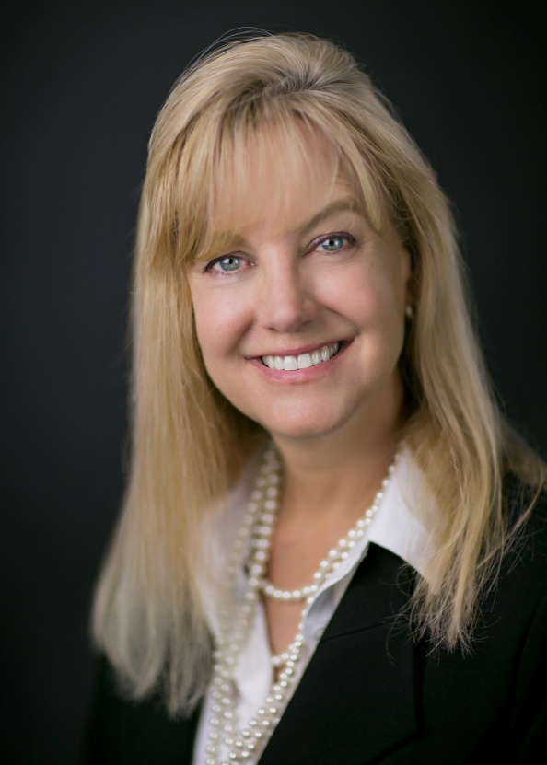

*Please attach a headshot photo with your submission*
A one-minute (max) campaign video may be submitted with questionnaire responses
Please return all responses by Wednesday, September 26th
Via e-mail to: stephanie.swanberg@tricityregionalchamber.com
Via fax: (509) 783-1733
Via mail: 7130 W. Grandridge Blvd., Suite C | Kennewick, WA 99336

Thank you for completing the questionnaire!

