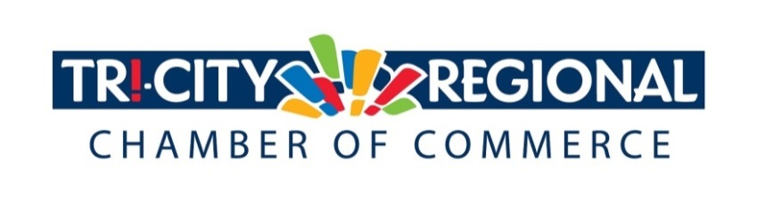
CANDIDATE QUESTIONNAIRE
2018 GENERAL ELECTION

Position: State Representative, Position 2

Candidate: Skyler Rude

Biographical Information:

- Education/Past & Present Employment/Business Experience

I have approximately 5 years of professional experience as an insurance agent, 3 years in telecommunications, and 3.5 years as Senator Walsh’s Legislative Assistant (2 sessions in the House and 2 in the Senate).

I have three years of college education and am currently enrolled in a business management program at Western Governor’s University online.

- Past & Present Community Involvement

I am the current Walla Walla County Republican Party Chairman and a longtime active member of my local party. In addition to my work and Republican activities, I have served on the Walla Walla Parks, Recreation and Urban Forestry Advisory Board, and been a recurring donor to Birth Right.

Candidate Questionnaire:

- Why are you running for office?

My campaign is about bringing people together for the good of our communities and families. My campaign slogan is “People before Politics” because I share the frustration of many folks that good policy often doesn’t move forward due to political games--I don’t operate that way. I believe it is important to be up front about policy positions so that trust can be built and maintained.

- What have you done to prepare for this position?

I have worked for this district as Senator Walsh’s assistant for both a long and short session in both the House and Senate. My years of experience working in the legislature, a thorough understanding of the process and the relationships that have been built in Olympia make me uniquely qualified to be effective as a legislator. The Senate and House are different in many ways. Understanding how each work is important when navigating a bill through the process. I bring that experience to the table as a candidate for this position.

- What are three actions you would support to strengthen small business and entrepreneurship?

Actions to reduce labor costs – I would support eliminating or reducing the last $1.50/hr scheduled minimum wage increase. I would also consider an Oregon style model for worker’s compensation by allowing a private option to complete with the public option.
Taxation – Taxes add to business operating costs. It is important the Legislature be cognizant of the negative impact additional costs have on small businesses. Legislators should look for areas to reduce unnecessary costs imposed on businesses.
Vocational Education – I strongly believe we should emphasize a variety of pathways to success, some of which include apprentice programs, certificates, two year degrees, etc. Our educational system should focus on supplying a diverse workforce by identifying high demand jobs and providing instruction and hands-on experience in those fields. This should include partnership with regional businesses.

- What do you believe is the greatest economic challenge facing our region and what would be your approach to address it?

General cost of living is one of the greatest challenges. This is a complex issue that involves many facets, some of which include rising healthcare costs, rising housing costs and increased cost of labor. Many students graduate from college with significant levels of debt. Minimum wage increases have led to increased labor costs for business and reduced entry level employment opportunities.

- If elected, what will be your top two priority issues and how will you facilitate these changes and/or ideas?

First, expansion of career training opportunities and preparedness in high school. As mentioned above, student loan debt is a significant burden for young people. Accumulating debt is appropriate, but only if the field of study prepares the student for a high demand field that pays well enough to ensure reasonable debt repayment. Apprenticeships, certificate programs and other opportunities are also viable and less costly options that can lead to good jobs.

Second, fiscal restraint and responsible budgeting are critical functions of state government. I am concerned the Legislature is neglecting the Rainy Day Fund (Budget Stabilization Account) when it should be setting aside funds in anticipation of the next recession. Failure to appropriately plan for long term financial stability is one of my greatest concerns. I am interested in reducing state debt by shifting away from grant programs in the capital budget to more loan programs. The Public Works Trust Fund is an excellent example of a program that helps facilitate low interest infrastructure financing for local jurisdictions and would be self-sustaining if the Legislature did not sweep its revenues regularly.

I’ve been endorsed by a variety of business organizations: Association of Washington Business, Washington State Farm Bureau, Washington Hospitality Association, Washington Food Industry Association, Washington Affordable Housing Council, and Washington Association of Realtors. I believe these endorsements demonstrate my awareness and understanding of business interests.

- Over 4500 Tri-Citians have already participated in the MyTri2030 Regional Vision project by helping to identify big opportunities that will benefit the entire region. In principle, do you support this community-driven effort? And as goals emerge, would you be interested in working together to advance regional initiatives?

Absolutely. The more we can engage communities in decision making, the better. Typically, those who have a vested interest in a given project or objective make more thoughtful decisions.

*Please attach a headshot photo with your submission*
A one-minute (max) campaign video may be submitted with questionnaire responses
Please return all responses by Wednesday, September 26th
Via e-mail to: stephanie.swanberg@tricityregionalchamber.com
Via fax: (509) 783-1733
Via mail: 7130 W. Grandridge Blvd., Suite C | Kennewick, WA 99336

Thank you for completing the questionnaire!

